**INDIA’S AGRICULTURAL CROP PRODUCTION ANALYSIS(1997-2021)**

1.Introduction:

1.1.overview:

**This report delves into the captivating realm of India’s agricultural cultivation,providing a comprehensive visual exploration of key aspects and trends in the agricultural sector.Through the visual representations,readers can gain valuable insights into crop production,seasonal variations,regional distribution,and overall production trends.These visualizations enable intuitive analysis,allowing stakeholders to uncover patters,identify areas of growth or concern,and make data-driven decisions.**

**1.2.Purpose:**

**By harnessing the power of Tableau,this report not only presnts the data in a visually appealing manner but also provides an interactive experience for readers to explore the intricacies of India’s agricultural cultivation.To extract the insights from the data and put the data in the form of visualizations,Dashboards and Story we employed Tableau tool.**

**2.Problem Definition &Design Thinking:**

2.1.Empathy Map

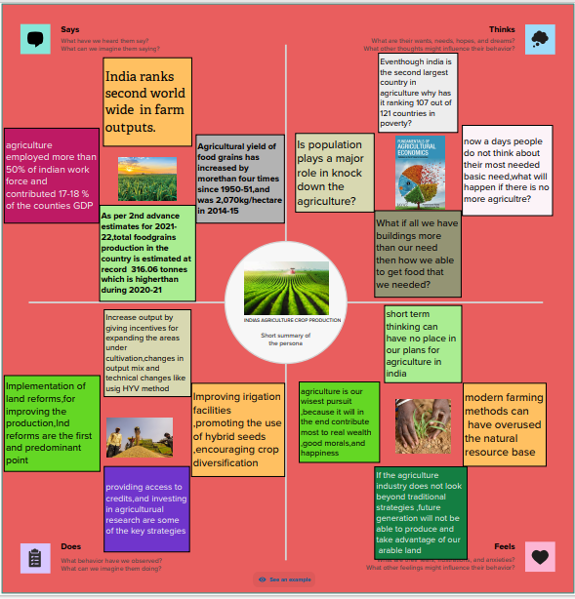

2.2 Ideation&Brainstorming Map

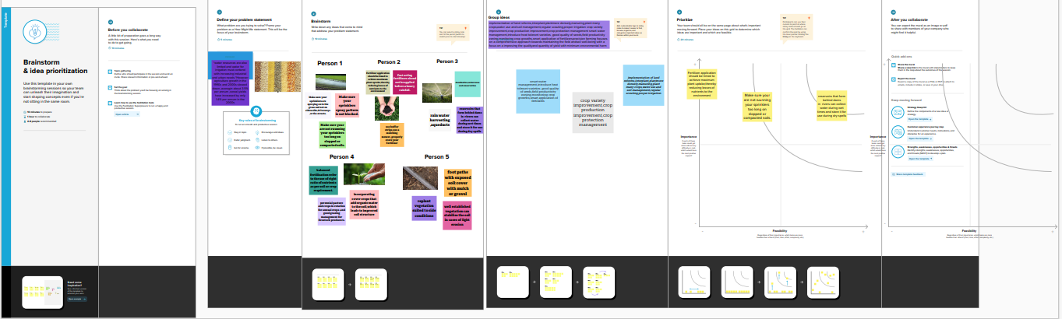

3.Result:

Dashboard:

**A dashboard is agraphical user interface that displays the information and data in an organised,easy-to-read format.Dashboards are often used to provide real-time monitoring and analysis of data and are typically designed for a specific purpose or use case.Dashboards can be used in variety of settings,such as business,finance,manufacturing,healthcare,and many other industries .They can be used to track key performance indicators,monitor performance metrics,and display data in the form of charts,graphs,and tables**

Dashboard 1

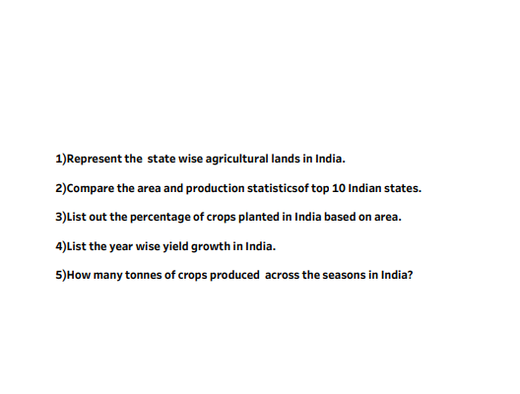

Dashboard 2

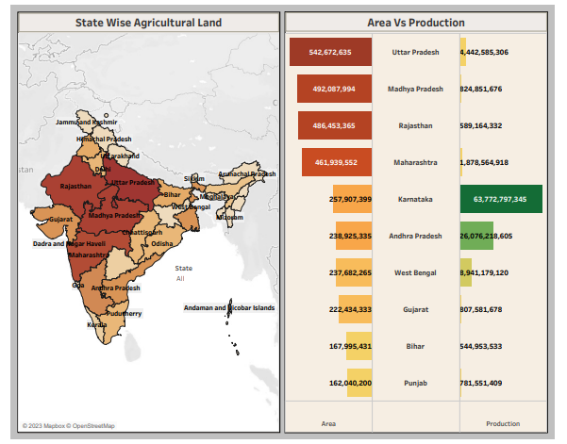

Dashboard 3

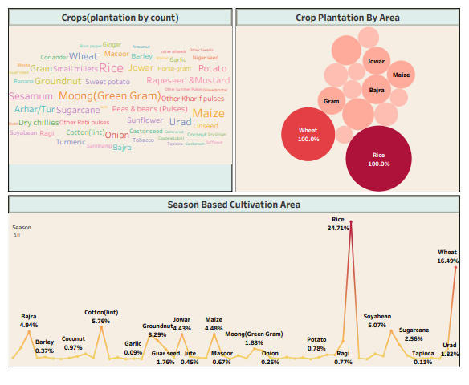

Dashboard 4

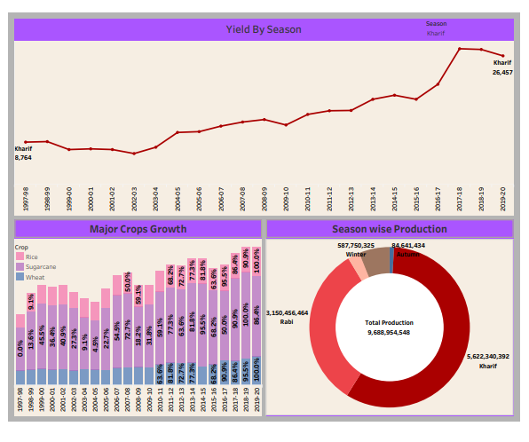

Story:

**A data story is a way of presenting data and analysis in a narrative format,intending to make the information more enganging and easier to understand.A data story typically includes a clear introduction that sets the stage and explains the context for the data,a body that presents the data and analysis logically and systematically,and a conclusion that summarizes the key findings and highlights their implications.Data stories can be told using a variety of** **mediums,such as reports,presentations,interactive visualizations,and videos.**

Story 1

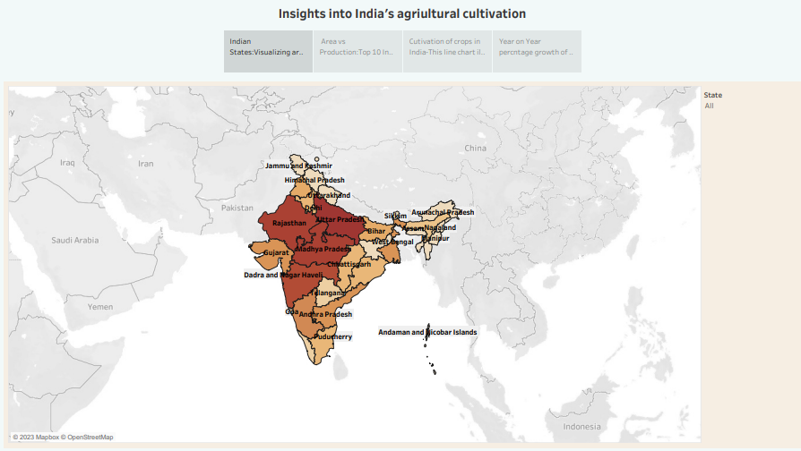

Story1

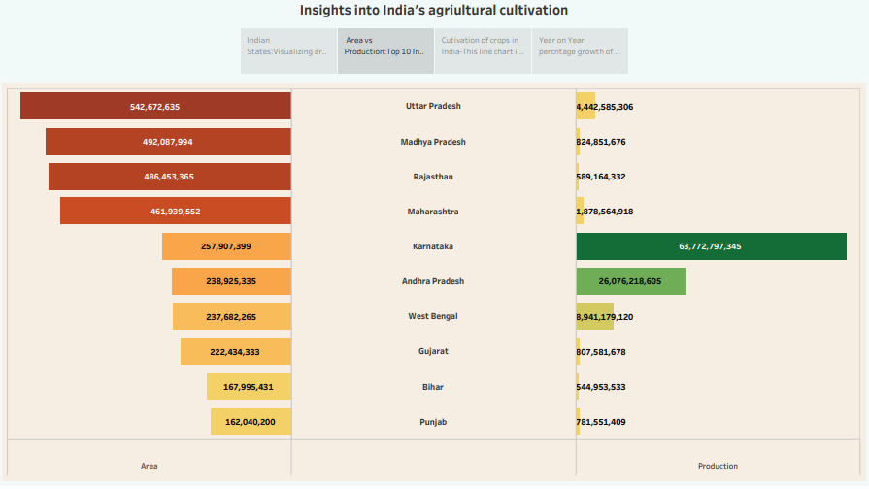

Story1

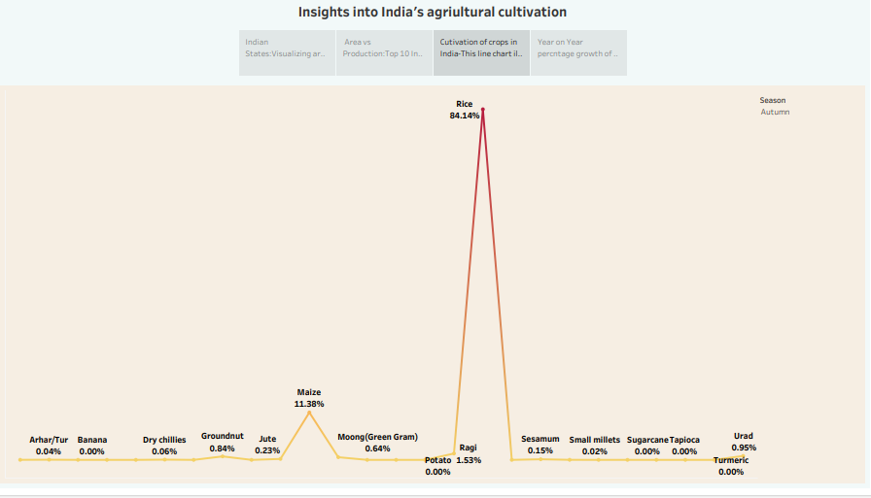

Story 1

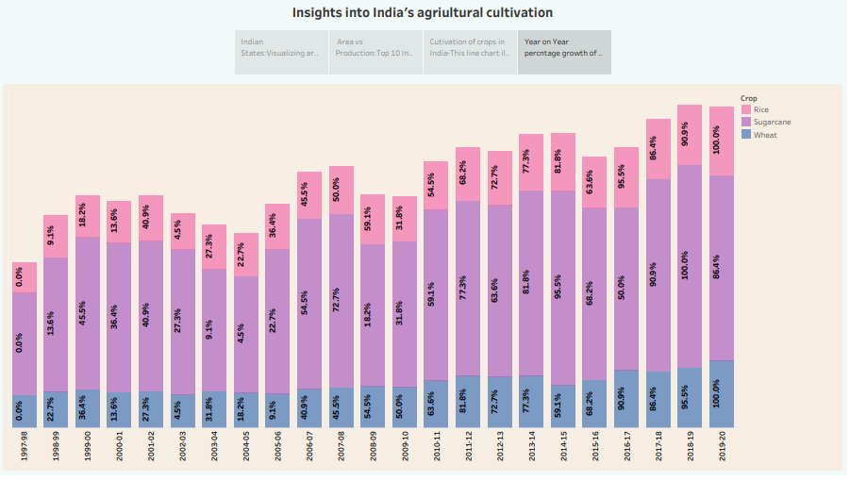

Story2

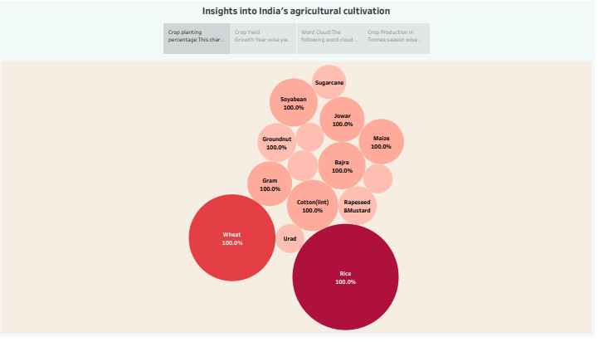

Story 2

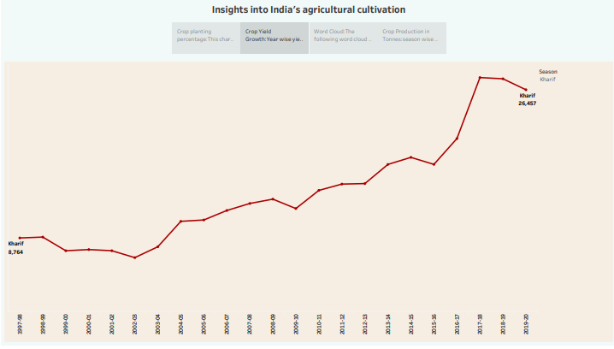

Story 2

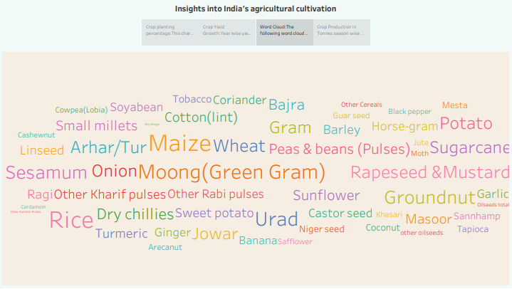

Story 2

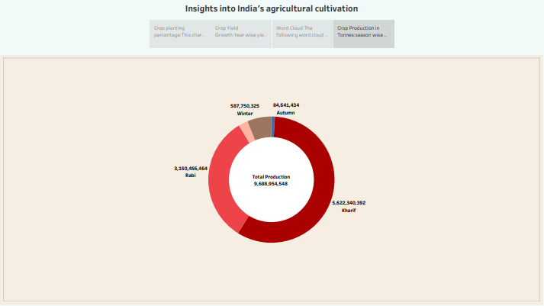

ADVANTAGES:

* **Higher crop productivity**
* **Decreased use of water quantity, fertilizer, and pesticides, which in turn keeps food prices down**
* **Reduced impact on natural ecosystems**
* **Less runoff of chemicals into rivers and also groundwater**
* **Increased worker safety**

DISADVANTAGES:

* **Uncertainty in the water supply**
* **Lack of remunerative income**
* **Fragmentation of land holdings**
* **Lack of access to formal credit and also insurance**
* **Allied infrastructure (market access and storage facilities)**

**APPLICATIONS:**

**The required level of investment for the development of marketing, storage and cold storage infrastructure is estimated to be huge. The government has not been able to implement schemes to raise investment in marketing infrastructure. Among these schemes are 'Construction of Rural Godowns' , 'Market Research and Information Network', and 'Development / Strengthening of Agricultural Marketing Infrastructure, Grading and Standardisation'.**

**CONCLUSION:**

[**Agriculture is a vital sector of the Indian economy, contributing about 17% to the total GDP and providing employment to around 58% of the population**](https://www.bing.com/ck/a?!&&p=e8827ecfcd772c31JmltdHM9MTY5Njg5NjAwMCZpZ3VpZD0xMmRlYTkyZC03ODMwLTY0MzctM2E4Yy1iYTUxNzk4MjY1ZjEmaW5zaWQ9NTY5MQ&ptn=3&hsh=3&fclid=12dea92d-7830-6437-3a8c-ba51798265f1&psq=conclusion+for+indian+agricultural+crop+production&u=a1aHR0cHM6Ly93d3cuaW5zaWdodHNvbmluZGlhLmNvbS9hZ3JpY3VsdHVyZS9yb2xlLW9mLWFncmljdWx0dXJlLWluLWluZGlhbi1lY29ub215Lw&ntb=1)[**1**](https://www.bing.com/ck/a?!&&p=5dc37a02f5a5dc95JmltdHM9MTY5Njg5NjAwMCZpZ3VpZD0xMmRlYTkyZC03ODMwLTY0MzctM2E4Yy1iYTUxNzk4MjY1ZjEmaW5zaWQ9NTY5Mg&ptn=3&hsh=3&fclid=12dea92d-7830-6437-3a8c-ba51798265f1&psq=conclusion+for+indian+agricultural+crop+production&u=a1aHR0cHM6Ly93d3cuaW5zaWdodHNvbmluZGlhLmNvbS9hZ3JpY3VsdHVyZS9yb2xlLW9mLWFncmljdWx0dXJlLWluLWluZGlhbi1lY29ub215Lw&ntb=1)**.**[**It is the largest industry in India and will always remain a significant factor in the nation’s economic growth**](https://www.bing.com/ck/a?!&&p=2b35ec040a9eca82JmltdHM9MTY5Njg5NjAwMCZpZ3VpZD0xMmRlYTkyZC03ODMwLTY0MzctM2E4Yy1iYTUxNzk4MjY1ZjEmaW5zaWQ9NTY5Mw&ptn=3&hsh=3&fclid=12dea92d-7830-6437-3a8c-ba51798265f1&psq=conclusion+for+indian+agricultural+crop+production&u=a1aHR0cHM6Ly9ieWp1cy5jb20vY2JzZS9lc3NheS1vbi1hZ3JpY3VsdHVyZS8&ntb=1)[**2**](https://www.bing.com/ck/a?!&&p=aba01a91b9c36966JmltdHM9MTY5Njg5NjAwMCZpZ3VpZD0xMmRlYTkyZC03ODMwLTY0MzctM2E4Yy1iYTUxNzk4MjY1ZjEmaW5zaWQ9NTY5NA&ptn=3&hsh=3&fclid=12dea92d-7830-6437-3a8c-ba51798265f1&psq=conclusion+for+indian+agricultural+crop+production&u=a1aHR0cHM6Ly9ieWp1cy5jb20vY2JzZS9lc3NheS1vbi1hZ3JpY3VsdHVyZS8&ntb=1)**.**

[**Although its contribution in the gross domestic product (GDP) has reduced to less than 20%, agricultural production has grown**](https://www.bing.com/ck/a?!&&p=320b12604e061cacJmltdHM9MTY5Njg5NjAwMCZpZ3VpZD0xMmRlYTkyZC03ODMwLTY0MzctM2E4Yy1iYTUxNzk4MjY1ZjEmaW5zaWQ9NTY5NQ&ptn=3&hsh=3&fclid=12dea92d-7830-6437-3a8c-ba51798265f1&psq=conclusion+for+indian+agricultural+crop+production&u=a1aHR0cHM6Ly93d3cuZG93bnRvZWFydGgub3JnLmluL2Jsb2cvYWdyaWN1bHR1cmUvdGhlLWZ1dHVyZS1vZi1pbmRpYW4tYWdyaWN1bHR1cmUtNzUzODQ&ntb=1)[**3**](https://www.bing.com/ck/a?!&&p=7426efe5c25dbf31JmltdHM9MTY5Njg5NjAwMCZpZ3VpZD0xMmRlYTkyZC03ODMwLTY0MzctM2E4Yy1iYTUxNzk4MjY1ZjEmaW5zaWQ9NTY5Ng&ptn=3&hsh=3&fclid=12dea92d-7830-6437-3a8c-ba51798265f1&psq=conclusion+for+indian+agricultural+crop+production&u=a1aHR0cHM6Ly93d3cuZG93bnRvZWFydGgub3JnLmluL2Jsb2cvYWdyaWN1bHR1cmUvdGhlLWZ1dHVyZS1vZi1pbmRpYW4tYWdyaWN1bHR1cmUtNzUzODQ&ntb=1)**.**[**The agricultural sector is undergoing a process of transition to a market economy, with substantial changes in the social, legal, structural, productive and supply set-ups**](https://www.bing.com/ck/a?!&&p=04c9f0905530511aJmltdHM9MTY5Njg5NjAwMCZpZ3VpZD0xMmRlYTkyZC03ODMwLTY0MzctM2E4Yy1iYTUxNzk4MjY1ZjEmaW5zaWQ9NTY5Nw&ptn=3&hsh=3&fclid=12dea92d-7830-6437-3a8c-ba51798265f1&psq=conclusion+for+indian+agricultural+crop+production&u=a1aHR0cHM6Ly93aXNkb21hbnN3ZXIuY29tL3doYXQtaXMtdGhlLWNvbmNsdXNpb24tb2YtYWdyaWN1bHR1cmUtaW4taW5kaWEv&ntb=1)[**4**](https://www.bing.com/ck/a?!&&p=7e75b3e23c3ab1f6JmltdHM9MTY5Njg5NjAwMCZpZ3VpZD0xMmRlYTkyZC03ODMwLTY0MzctM2E4Yy1iYTUxNzk4MjY1ZjEmaW5zaWQ9NTY5OA&ptn=3&hsh=3&fclid=12dea92d-7830-6437-3a8c-ba51798265f1&psq=conclusion+for+indian+agricultural+crop+production&u=a1aHR0cHM6Ly93aXNkb21hbnN3ZXIuY29tL3doYXQtaXMtdGhlLWNvbmNsdXNpb24tb2YtYWdyaWN1bHR1cmUtaW4taW5kaWEv&ntb=1)**.**

FUTURE SCOPES:

**A crop monitoring device is another major element of precision farming.**

**Similar to weather forecasting stations, these devices are placed in the farm to collect data necessary for farming, including the temperature of the soil, precipitation to leaf water potential, as well as overall crop growth.**